**大数据作业1 MySQL**

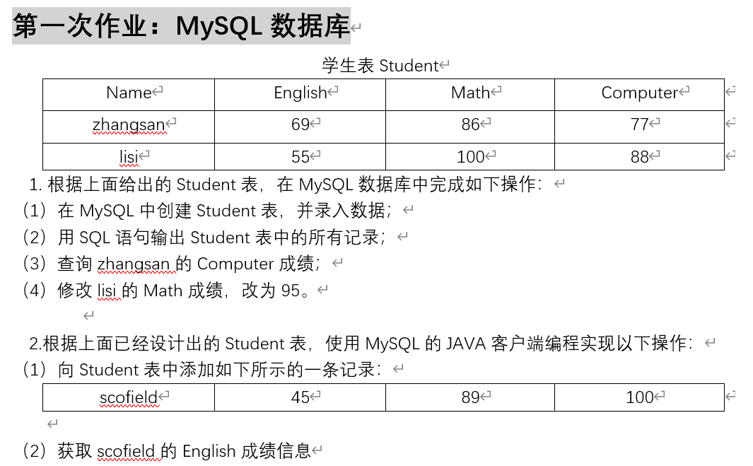

1. (1)

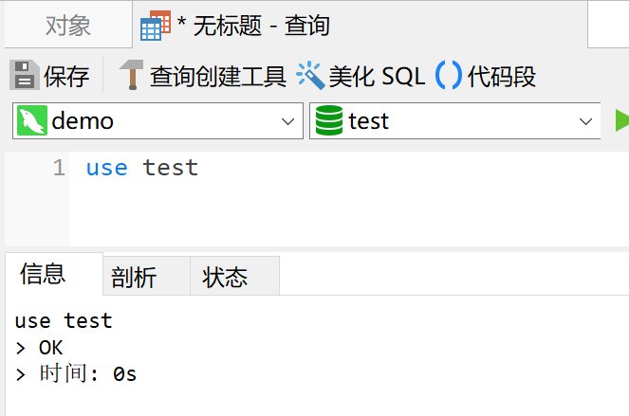 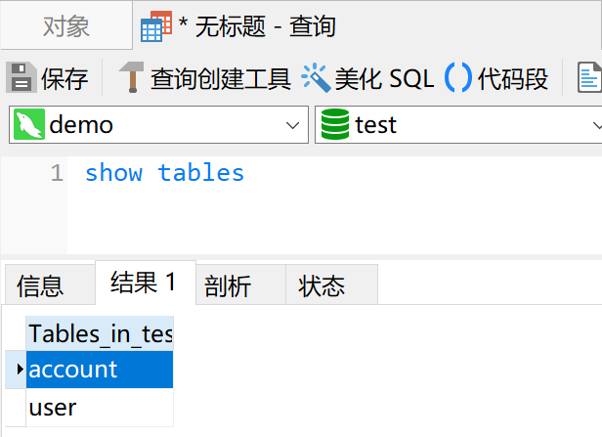

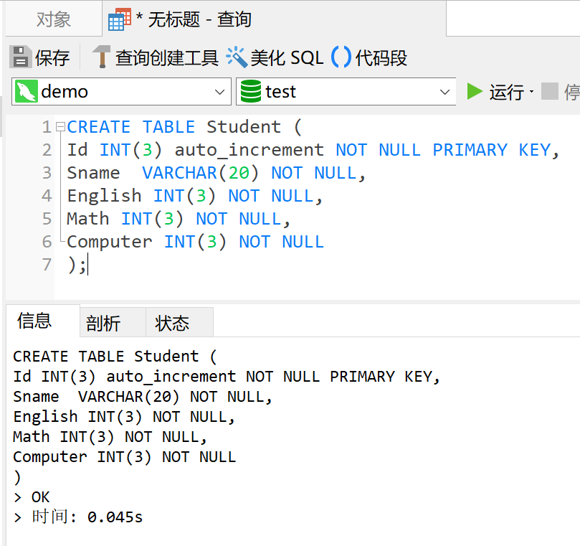

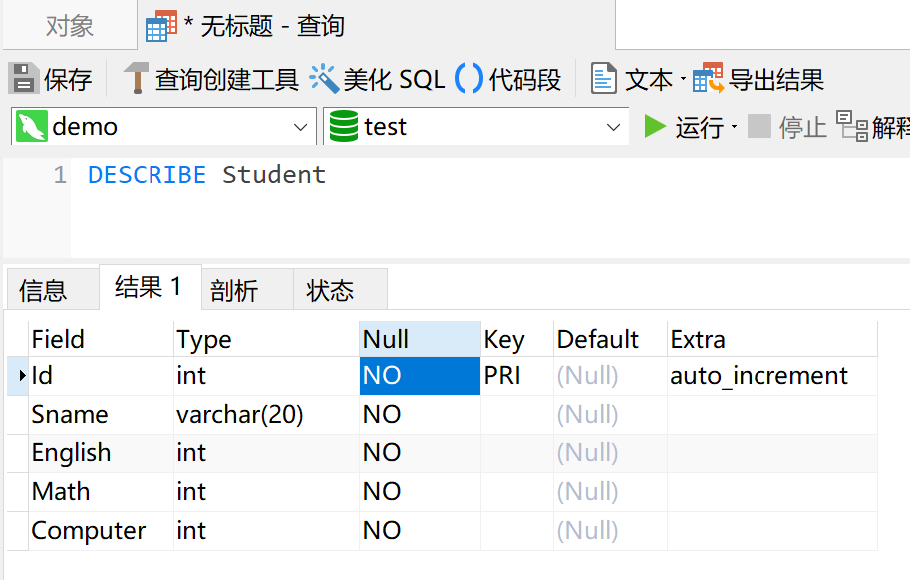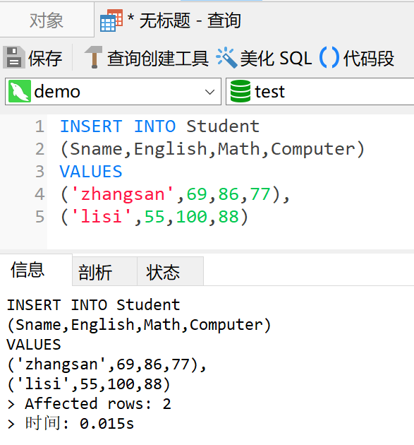

(2)

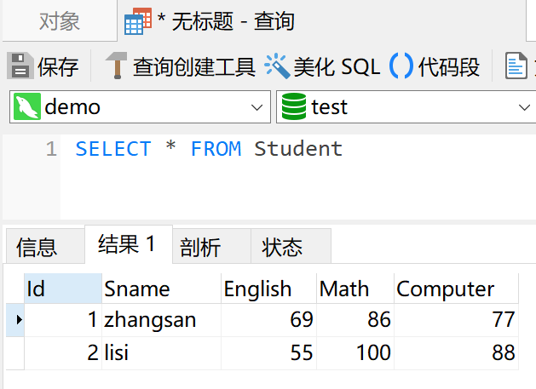

1. (4)

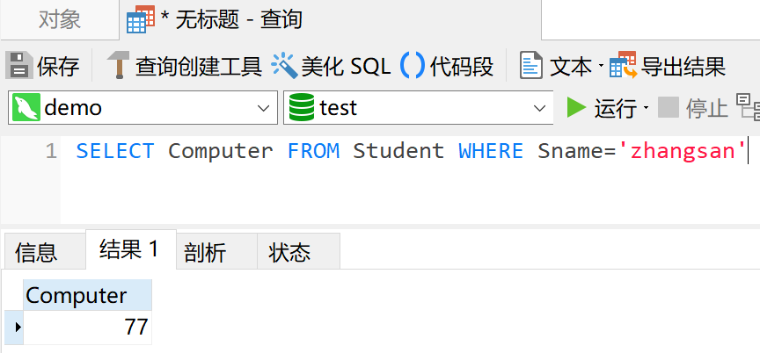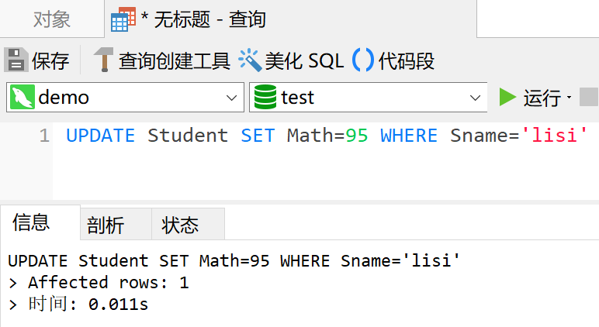

2.编程实现：

**import** java.sql.*;

**public** **class** testMysql {

**static** **final** String ***DRIVER***="com.mysql.cj.jdbc.Driver";

**static** **final** String ***DB***="jdbc:mysql://localhost:3306/test?serverTimezone=UTC";

**static** **final** String ***USER***="root";

**static** **final** String ***PASSWD***="1111";

**public** **static** **void** main(String[] args) {

Connection conn=**null**;

Statement stmt=**null**;

**try** {

Class.*forName*(***DRIVER***);

System.***out***.println("Connecting to a selected database...");

conn=DriverManager.*getConnection*(***DB***, ***USER***, ***PASSWD***);

stmt=conn.createStatement();

//更新

// String sql="insert into Student(Sname,English,Math,Computer) values('scofield',45,89,100)";

// stmt.executeUpdate(sql);

// System.out.println("Inserting records into the table successfully!");

//查询

// String sql="select English from Student where Sname='scofield'";

String sql="select * from Student";

ResultSet rs=stmt.executeQuery(sql);

// if (rs.next()) System.out.println("scofield's English score is "+rs.getString(1));

**while**(rs.next()) {

System.***out***.println(rs.getString(1)+" "+rs.getString(2)+" "+rs.getString(3)+" "+rs.getString(4)+" "+rs.getString(5));

}

System.***out***.println("Query successfully!");

} **catch** (Exception e) {

e.printStackTrace();

}

**finally**{

**if**(stmt!=**null**)

**try** {

stmt.close();

} **catch** (SQLException e) {

e.printStackTrace();

}

**if**(conn!=**null**)

**try** {

conn.close();

} **catch** (SQLException e) {

e.printStackTrace();

}

}

}

}

(1)添加一条记录：

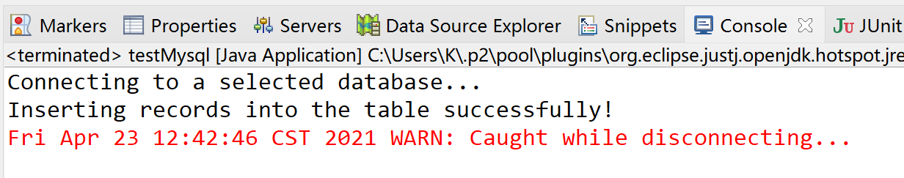

查询所有记录验证添加成功：

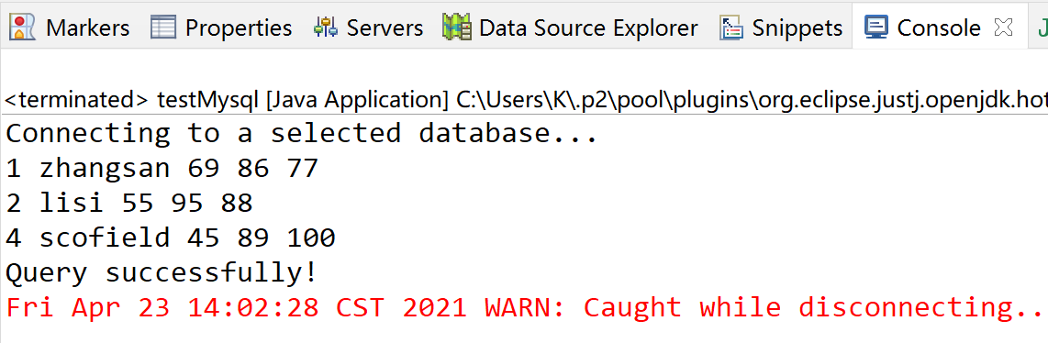

查看数据库 添加成功：

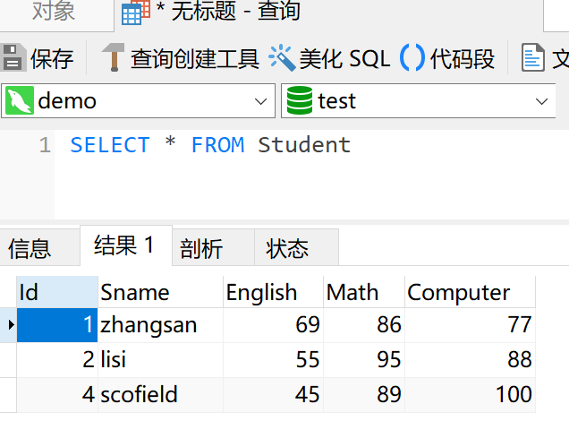

(2)

